Project Design Phase-II

Data Flow Diagram & User Stories
Date | 18 October 2026
Team ID
Project Name | Wayfarer - Personalized Travel Itinerary Planner
Maximum Marks | 4 Marks

A Data Flow Diagram (DFD) shows how data moves through Wayfarer: how the traveller interacts with the system, which components process the data and where it is stored.

DFD Level 0 (Context)
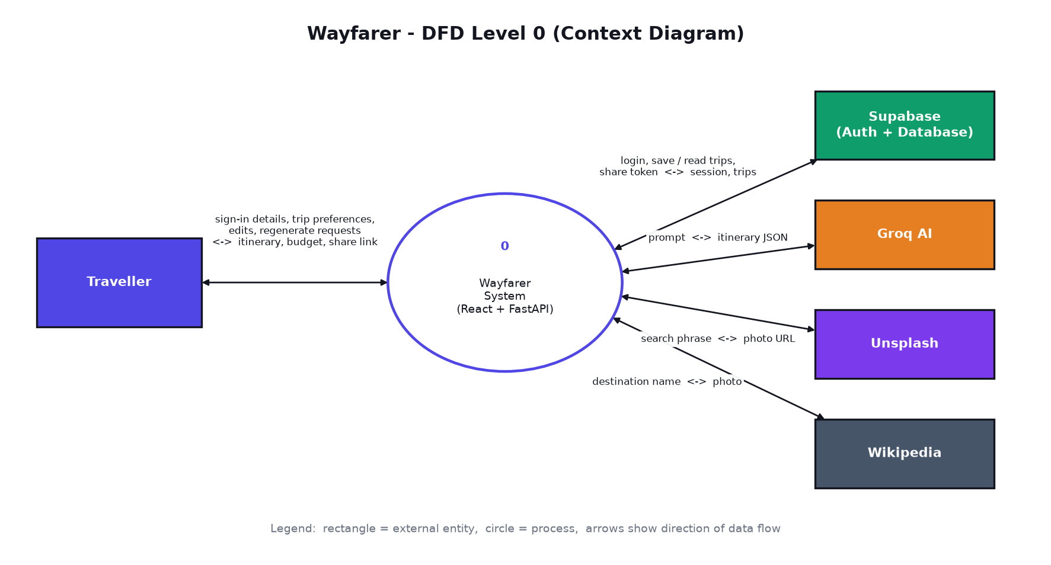
Traveller  (enters preferences) | Wayfarer System | Groq AI | Unsplash  (external services)
Traveller -> Wayfarer: sign-in details, trip preferences, edits, regenerate requests. Wayfarer -> Traveller: itinerary, budget summary, share link.
Wayfarer <-> Groq AI: prompt out, structured itinerary JSON back. Wayfarer <-> Unsplash: search phrase out, photo URL back. Wayfarer <-> Wikipedia: destination name out, destination photo back. Wayfarer <-> Supabase: login, trips and share tokens.

DFD Level 1
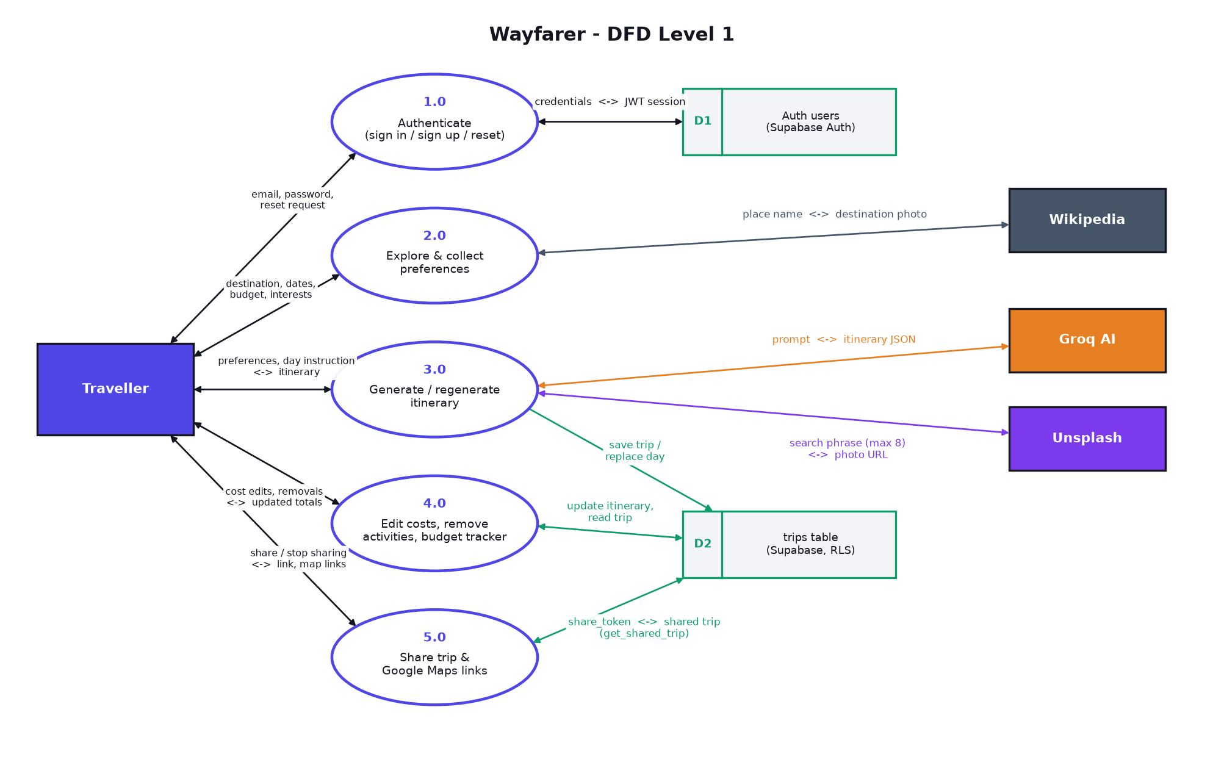
Step | Process | Data flow
1 | Authenticate (Supabase Auth) | Traveller sends email and password (or a password-reset request); Supabase returns a session token (JWT) or emails a reset link that opens /reset.
2 | Explore & collect preferences (React) | Traveller picks a destination card (photos fetched from Wikipedia) or searches any place; the form is pre-filled. Traveller submits destination, dates, budget, interests, pace, stay type, notes.
3 | Verify user (FastAPI) | Frontend sends preferences with the JWT; backend checks the token with Supabase Auth.
4 | Generate itinerary (FastAPI -> Groq) | Backend builds a prompt, calls Groq, receives JSON, validates it and recomputes costs.
5 | Attach photos (FastAPI -> Unsplash) | Backend requests a cover photo and photos for up to 8 sightseeing/experience activities (cached, in parallel). Activities without a photo show a placeholder icon in the UI.
6 | Save trip (React -> Supabase) | Frontend stores preferences and itinerary in the trips table (protected by RLS).
7 | Edit / regenerate (React, FastAPI) | Cost edits and removals are saved to Supabase; a regenerated day comes back from the backend and is saved.
8 | Share (Supabase function) | Owner creates a random token; a viewer opens /share/<token> and the get_shared_trip function returns only that trip.

User Stories
User Type | Functional Requirement (Epic) | User Story / Task | Acceptance Criteria | Priority | Release
Traveller | Authentication | As a user, I can sign up and sign in. | I reach my dashboard after signing in. | High | Sprint-1
Traveller | Preference Collection | As a traveller, I can enter my trip preferences. | Form validates dates and budget. | High | Sprint-2
Traveller | Itinerary Generation | As a traveller, I get a day-by-day itinerary. | Each day has activities with time, cost and photo. | High | Sprint-2
Traveller | Dashboard | As a user, I can see my saved trips. | Saved trips appear with summary stats. | High | Sprint-2
Traveller | Personalisation | As a traveller, I can edit costs and remove activities. | Totals update and changes are saved. | High | Sprint-3
Traveller | Personalisation | As a traveller, I can regenerate one day. | Only that day changes; no repeated places. | High | Sprint-3
Traveller | Navigation | As a traveller, I can open places and routes in Google Maps. | Map links open the right location. | Medium | Sprint-3
Traveller | Sharing | As a traveller, I can share a read-only link. | Link works without login and can be turned off. | Medium | Sprint-4
Traveller | Explore | As a traveller, I can browse popular destinations with photos and start a trip from one. | Destination card opens the trip form pre-filled; India list expands with See all. | Medium | Sprint-4
Traveller | Authentication | As a user, I can show/hide my password and reset a forgotten one by email. | Reset link opens /reset and the new password works. | Medium | Sprint-4

